**2023**

**Year 12 Integrated Science – Unit 4**

**Task 10: Physics and Newton’s Laws Test**

**Assessment Type: Test**

**Weighting: 5%**

**Duration: 45 minutes**

**MARKING KEY**

**Name: _____________________**

**Date: ______________________**

|  |  |
| --- | --- |
| **Multiple Choice** |  |
| **Short Answer** |  |
| **Extended Answer** |  |
| **Total Mark** |  |

*Please see SEQTA for teacher feedback and comments.*

**MULTIPLE CHOICE:**

1. What is the energy possessed by a moving object called?
   1. Potential energy
   2. Mechanical energy
   3. Kinetic energy
   4. Thermal energy
2. Which of the below examples represent potential energy?
   1. A moving car
   2. A rolling ball
   3. A book sitting on a shelf
   4. A spinning top
3. What is the **difference** between speed and velocity?
   1. Speed includes direction, velocity does not
   2. Velocity includes direction, speed does not
   3. Speed is a scalar quantity, velocity is a vector quantity
   4. Speed in measured in ms2, velocity is measured in ms1
4. A car accelerates from 15m/s to 30m/s in 5s. What is its acceleration?
   1. 3ms2
   2. 5ms2
   3. 10ms2
   4. 15ms2
5. According to Newton’s first law of motion, an object will remain at rest unless:
   1. A force is applied to it
   2. It gains potential energy
   3. It experiences acceleration
   4. Its mass changes
6. Newton’s second law of motion can be written as:
   1. F = m x a
   2. F = m + a
   3. F = m / a
   4. F = m – a
7. Using Newton’s second law of motion formula, if an 8kg object has an acceleration of 3ms2, how much force has been applied to it?
   1. 16N
   2. 35N
   3. 8N
   4. 24N
8. How are potential energy and kinetic energy related in a simple pendulum scenario?
   1. They are equal at all times?
   2. Potential energy is maximum at the lowest point
   3. Kinetic energy is maximum at the highest point
   4. The sum of Potential and Kinetic energy remains constant throughout the motion
9. To investigate the relationship between the angle of an inclined plane and the acceleration of a rolling ball, what should you measure?
   1. 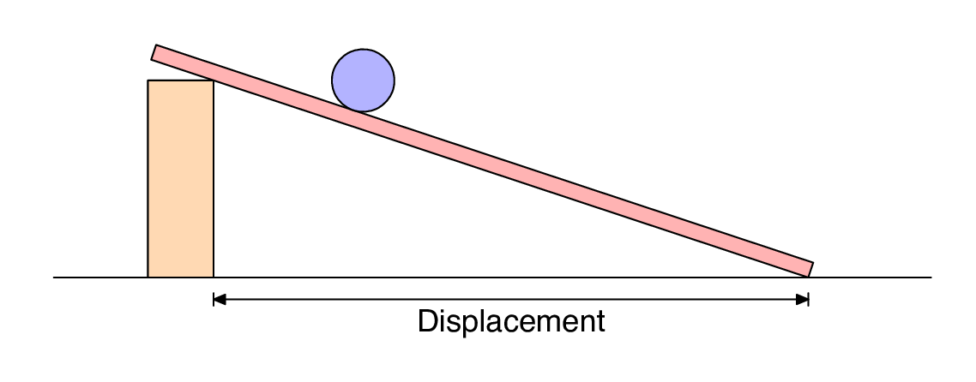The mass of the ball
   2. The time taken to roll down
   3. The length of the inclined plane
   4. The force applied to the ball
10. Which of the following can best be explained by Newton’s first law?
    1. A bicycle will slow down on a level road when the rider stops pedalling
    2. A passenger without a seatbelt will be thrown forward when the car breaks
    3. The acceleration of a rocket is related to the mass of the rocket
    4. A moving toy car will bounce backwards upon hitting a wall
11. What is Newton’s third law?
    1. Law of gravity
    2. Law of action-reaction
    3. Law of force and acceleration
    4. Law of inertia
12. In a collision between a heavy truck and a small car, which is more likely to experience acceleration after the collision?



* 1. The truck
  2. The car
  3. Both the same
  4. Depends on the forces involved

**END OF MULTI-CHOICE SECTION**

**GO TO SHORT ANSWER SECTION**

**SHORT ANSWER:**

1. Cars have many safety features designed to protect the driver and its passengers.
   1. Explain why a seatbelt is required in a car. (1 mark)

To stop a person moving in the car when it is hit or suddenly breaks

* 1. Identify which of Newton’s laws relates to this scenario and state the definition of this law. (2 marks)

1 mark – inertia

1 mark – an object on motion or at rest will remain at rest until acted upon by an external force

* 1. Explain the importance of the seatbelt using Newton’s laws to explain. Use your answers from part a. and b. to assist you. (2 marks)

1 mark - To stop/reduce a person’s inertia

1 mark – It is Newton’s first law in action

1. Choose one of Newton’s Laws to explain the following images (there is more than one correct answer). (4 marks)

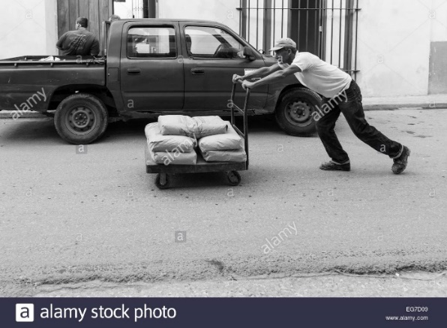

1 mark – identify any of newton’s laws

1 mark – explain how it works in this picture

1 mark – any of newton’s laws

1 mark – explain how it works in this picture



1. Using the formula answer the following questions
   1. A force of 30M accelerated an object by 15ms2. What is the object’s mass?

(2 marks)

1 mark – shows correct working

1 mark – correct answer with correct units

* 1. A force of 40N to the left is applied to a toy car with a mass of 750g. Calculate its acceleration (including direction). (2 marks)

1 mark – shows correct working

1 mark – correct answer with correct units

1. Using the formula or (where gravity = 9.8ms2), answer the following questions.
   1. Calculate the Kinetic energy of a bicycle with a mass of 10kg moving at 6m/s.

(2 marks)

1 mark – shows correct working

1 mark – correct answer with correct units

* 1. A 5kg statue is raised to a height of 8m above the ground. Calculate its potential energy. (2 marks)

1 mark – shows correct working

1 mark – correct answer with correct units

**END OF SHORT ANSWER SECTION**

**GO TO EXTENDED ANSWER SECTION**

**EXTENDED ANSWER:**

Imagine that a car is travelling on a straight road. The driver sees a problem on the road ahead and so brakes suddenly to stop. The **stopping distance** is the distance that the car travels from the moment that the brakes are applied to the moment that the car stops.

If the car is initially travelling at ms-1, then the stopping distance m travelled by the car is given by:

For example, if the car was initially travelling at 10ms-1 before the brakes were applied the stopping distance would be:

(5 metres)

ms-1

1. Using the formula above, calculate the stopping distance for the following speeds in the table below. The first one has been done for you. (3 marks)

|  |  |
| --- | --- |
| **Initial Speed** *u* (m/s) | **Stopping distance** *d* (m) |
| 10 | 5 |
| 20 | 20 |
| 30 | 45 |
| 40 | 80 |
| 50 | 125 |
| 60 | 180 |
| 70 | 245 |

1. Using the table in question 1, graph the relationship between initial speed and stopping distance. (5 marks)



1 mark - title

1 mark - correct axis labels

1 mark – even scale on both axis

1 mark – data plotted correctly

1 mark – correct units on labels

1. Using the graph in question 2, predict how far you would travel before you come to a stop when travelling at 35m/s. (1 mark)

Approx. 50-60m

1. Use the graph to predict how fast you would be travelling if you took 150m to stop.

(1 mark)

Approx 50-60m

1. What external force helps stop the car when you apply the brake? (1 mark)

Friction

**END OF ASSESSMENT**